Zoom Guide for Students

Writing Salon classes are hosted via Zoom, a videoconferencing service that is straightforward, easy to use, and well designed for online classes. We request that you come to class prepared to manage your own Zoom experience. Below we’ve shared helpful tips to ensure that you’re familiar with Zoom and prepared to take a class at The Writing Salon.
Preparing for Your Zoom Class
To attend class meetings, you'll need a computer, tablet or phone, and access to the internet. You can participate in the class from wherever you'd like, whether on your living room couch or in your home office.

If you don't have Zoom on your computer, you'll need to download the software prior to your class. If you’ll be using a mobile device, please download the Zoom application onto your phone. We strongly recommend all participants attend by computer, if possible, to ensure best access to all class materials.

To participate in our classes, you do not have to create a Zoom account. If you don’t have a device with video capability, you'll still be able to join and view your class. Just note that the instructor and your fellow students won't be able to see you.

Captions are available for all our online classes. Reach out to your instructor ahead of class to communicate your request, or contact us at hello@writingsalons.com.

Joining Your Class Meetings on Zoom

2-3 days before your Writing Salon class, you’ll receive a welcome email with your class Zoom link and meeting ID. Plan to join your class 10-15 minutes early.

There are a few different ways you can access your class:
- Click on your class link in the welcome email. You’ll then be added to your online classroom.
- If you have the Zoom application on your computer, you can join using the Meeting ID. Open the app on your computer, and click “Join a Meeting”:
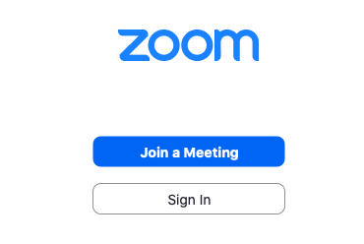
You’ll then be prompted to add your Meeting ID and your name:
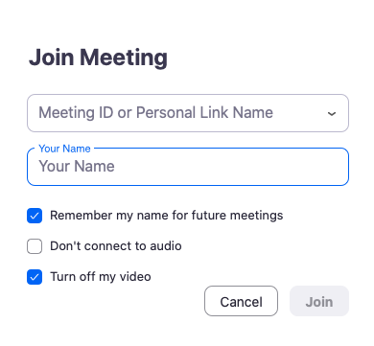

- To access your class with the Meeting ID without downloading the Zoom application onto your computer, visit www.zoom.us. At the top right of the screen, click “Join A Meeting”:

You’ll be prompted to add the Meeting ID:

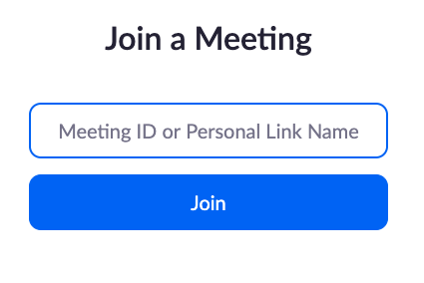

*After selecting any of the three options listed above, follow the prompts on your screen to join the class:

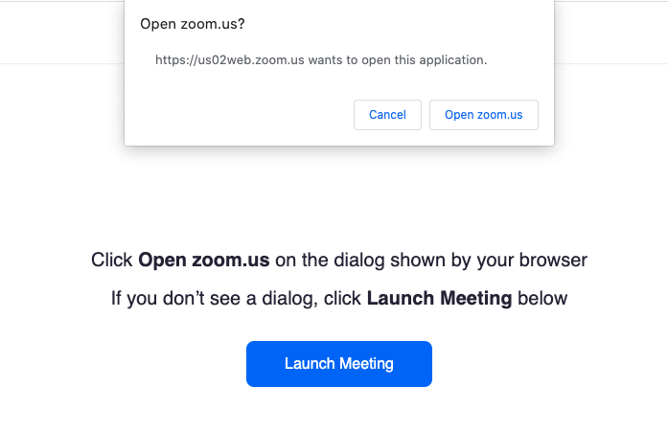
Troubleshooting & Testing Zoom

We ask our students to have basic competency over the main Zoom controls, particularly the mute/unmute and video on/off functions, before joining a classroom.

If you're not sure how to join a Zoom meeting, click here. At this webpage you'll find information for joining a Zoom meeting from multiple devices.

If you are new to Zoom, we recommend that you join a test meeting space at https://zoom.us/test to test out your audio and video and to become familiar with Zoom.

Learning Zoom Controls

The Zoom toolbar is located at the bottom of your screen. This toolbar will “hide” if your mouse is inactive. Dragging your mouse across the screen will bring up this toolbar:

On the left hand side of the toolbar you will see your audio and visual controls where you’re able to mute your video, change your microphone settings, and start and stop your video. During a class meeting, if you ever have an issue broadcasting your video or audio, look first at your Zoom toolbar. If you see a red line through either your microphone or video icon, you have muted yourself or turned off your video. Clicking the icon with the red line through it should turn your video or audio back on.

Managing Audio & Video During Class

During a class meeting, it’s generally a good idea to mute yourself when you are not speaking in order to eliminate any audio feedback or background noise. In case there are any audio feedback issues with your computer's mic or background noise, be prepared to use headphones or earbuds with a mic.

If there are any distractions in your background—if you are in a busy place, if there are children in the area, or if there’s anything else in your environment that might impact other students’ ability to focus on class—we ask that you turn your video off and/or that you mute your audio or wear headphones or earbuds with a mic.

Using the Chat Function During Class

You can use your chat function to ask questions and share links. Click the chat icon to pull up the chat. Bear in mind that what you post in the chat will be sent to everyone in your class. Chatting directly with one student or your teacher also is not private since your chats are archived. Please be considerate of your classmates and teachers while using chat.

While some instructors do make use of the chat function, it can be challenging for them to respond to specific chat requests and navigate teaching the class at the same time. Aside from emergencies, it’s best not to use chat if you are seeking accommodations. Instead, email your instructor well before a class meeting to communicate your request.
Receiving Zoom Support

If you need any support, Zoom has great online tutorials. For general guidance, we recommend visiting the Zoom Help Center. To learn the basics, check out this 10-minute video: How to Use Zoom.

